Computer Architecture I

Final Project Report

Accumulator

Team 4D

An Hu

Donai Long

Bo Peng

Jackie Preston

Table of Contents

Section Page Number

Executive Summary…………………………………………………… 1

Introduction…………………………………………………………… 2

Body…………………………………………………………………… 3

* Instruction Set Design ....…………………………………. 3
* Implementation……….…………………………………… 6
* Xilinx Model ………….………………………………….. 7
* Testing …………………………………………..………… 8
* Final Results ……………………………………………… 9

Conclusion ……………………………………………………………. 10

Appendices ……………………………………………………………. 11

* Appendix A – Design Documentation ………………………... 11
* Appendix B – Design Process Journal ………………………. 41
* Appendix C – Testing ……………………………………….. 44

Executive Summary

The purpose of the project was to correctly implement a processor of our own design. The first step was to decide what type of processor to build. We chose to implement an accumulator processor because it was different from the processor discussed in class but not so different as to give us problems in implementing it. We then decided how to implement the instructions, what the assembly language specifications were, and what the machine language specifications were. All of the registers available were described as well as how they were to be used.

The next step was to decide how to write the RTL code for each instruction. The RTL code was modified throughout the project. We then decided what components and signals were needed and described each of them. We also described any tests needed to verify the RTL.

The datapath was then designed based on the RTL code and the components needed. Descriptions were then given for the integration tests needed to implement the datapath. After that we designed the control unit for the datapath and gave descriptions for the tests needed.

All of the components were then integrated using Xilinx. Actual integration testing was begun here. The datapath was built from the bottom up using the integration tests described previously. Components were combined until the entire datapath was assembled. After the final model was built data collection was begun.

Introduction

The goal of this project was to build a “miniscule instruction set” general purpose processor that could run simple programs stored in an external memory. After designing the processor, we modeled the design using the program Xilinx and used the model to test, debug, and asses the performance of the design. The project was broken down into six milestones in order to give some direction as to what parts of the design should be done when.

The external memory communicated with the processor using a 16-bit address bus, a 16-bit data bus, a method for input that does not require the design to be recompiled to make changes to the demo code, and a method for output that allows the results of the computations to be easily viewed. The instruction set must be able to perform general computations and must support parameterized and nested procedures.

The design of the general purpose processor was evaluated on the ability to do general purpose computations, the performance of the calculations, the resources required for the design, and the interestingness of the design. One program that the processor must be able to run is a program that uses Euclid’s algorithm to compute the relative prime value of a number.

Each step of the process was documented in three different documents. The first was the design document, which described the design as it was made, including all choices made in regards to the design. The second was the design process journal, which recorded the process of the development of the design, including the reasoning behind the decisions made. The final document was the memo, which told the current status of the project. A memo was turned in for every milestone of the project.

Instruction Set Design

For this project we decided to build an accumulator-type processor. We chose an accumulator over a stack-based design because the accumulator was the most advantageous for the skill set of the group. We chose it over a load word-based design because the accumulator was faster than the load word type. The processor uses two registers instead of one in order to make the instruction implementation easier by allowing us to compare two instructions and in order to make the processor faster. The instructions and machine language were implemented in hexadecimal. This was chosen over binary because hexadecimal was easier for humans to translate and read and was chosen over decimal because hexadecimal was easier for the processor to translate and read.

The size of the instructions was chosen to be 16 bits. In the register, bit 0 was chosen to be the Register. This bit had two options for its value, 0 or 1. If the value was 0, the register $t, which saved temporary values, was used. If the value was 1, the register $s, which saved values that would be needed in the future, was used. Bits 1 through 8 were chosen to be the Address. Bits 9 through 11 were chosen to be Extra Space. For R-Type instructions, these bits were just extra space. For I-Type instructions, these bits were combined with the Address bits to form the Immediate. For B-Type instructions, which are Branch on Equal and Branch on Not Equal, these bits were the Immediate. Bits 12 through 15 were chosen to be the Op code.

We chose to make our processor multi-cycle instead of single cycle or pipeline. Multi-cycle was chosen because it is faster than single cycle but less complicated than pipeline. We decided that the following components were needed:

* Program Counter (PC) – keeps track of the address of the current instruction
* Memory – stores instructions
* Instruction Register (IR) – register containing the current instruction
* Register File (RF) – deals with the loading and storing of registers
* ALU – does simple operations with two inputs
* Control Unit – translates the operation code to specified control signal bits
* Memory Data Register (MDR) – stores temporary value read from the memory
* I – takes immediate value from instruction
* BI – takes branch immediate value from instruction
* UA – takes upper address from instruction
* R – takes register value from instruction

We decided that the following control signals were needed:

* PCSource – controls the source of PC
  + Values: 0 = R, 1 = ALUout, 2 = target address for jumps
* ALUsrc1 – controls the input of ALU
  + Values: 0 = immediate, 1 = branch immediate, 2 = 1
* ALUsrc2 – controls the input of ALU
  + Values: 0 = from register file, 1 = MDR, 2 = PC
* PCWrite – enables or disables writing to the PC
  + Values: 0 = disable, 1 = enable
* MemRead – enables or disables reading from Memory
  + Values: 0 = disable, 1 = enable
* IRWrite – enables or disables writing to the Instruction Register
  + Values: 0 = disable, 1 = enable
* RegWrite – enables or disables writing to the Register File
  + Values: 0 = disable, 1 = enable
* RegSrc – determines what goes to the register
  + Values: 0 = sign extended immediate, 1 = MDR, 2 = UA shifted left by 8, 3 = PC, 4 = ALUout
* ALUoutSrc – determines what the output should be in the ALUout
  + Values: 0 = address beginning with 5 bits from PC, 1 = result from ALU, 2 = sign extended immediate
* ALUOp – determines what operation should be used in the ALU
* IorD – controls which part should be written back

The C code, Assembly code, and Machine Language translations were written for both Euclid’s Algorithm and another program written to test load and store words. The RTL code was then written for each instruction. Each instruction had between three and five steps for the RTL code. The instructions with three steps were jump, jump register, branch on equal/not equal, load upper immediate, and load immediate. The instructions with four steps were and/or/sub/add/set-less-than and add immediate. The instruction with five steps were load word/store word, jump and link, and return. The first two steps were the same for every instruction, as described below:

Step 1: IR is set equal to the memory value of PC, and the PC is incremented by one

Step 2: R is set equal to the register of the value at the IR at bit 0, I is set equal to the value of the IR at bits 11 to 1, BI is set equal to the value of the IR at bits 11 to 9, UA is set equal to the value of the IR at bits 8 to 1, and ALUOut is set equal to PC plus the sign extended value of IR at bits 11 to 1.

The RTL code for branch on equal/not equal is as described below:

Step 1: same as above

Step 2: same as above

Step 3: R and BI are compared. If R and BI are equal, then PC is set equal to ALUOut

The RTL code for the remaining instructions is addressed in Appendix A.

Implementation

Towards implementation, the datapath was drawn from the RTL code. Once we decided to build a multi-cycle datapath, we used the multi-cycle datapath given in class as reference for designing our own datapath. We decided that there were a few control signals that we did not need to use because we were using only two registers. These signals were PCWriteCond, IorR, MemWrite, and RegDst. The MemWrite and IorR signals were replaced with another port in the MemRead mux. One complication that arose with the datapath was adapting it to match our RTL code, which used fewer registers and was smaller than the version given in class. The control unit was designed from the RTL code and the datapath. The control signals were given for every RTL instruction.

We then decided how we would test the datapath after it was built in Xilinx. Each part of the datapath needed to be tested individually and then combined with other parts to fully test each part. We decided the components that needed to be individually tested were the memory, the control, the ALU, the IR, and the MDR.

The individual components of the datapath were built in Xilinx. The components that are 16-bit registers, PC, IR, MDR, and ALUout, were created using a flip-flop. The Memory and Zero Extend were created using Verilog. The muxes were created using the symbols in Xilinx. The 11-bit register I, the 3-bit register BI, and the 8-bit register UA were created using a flip-flop. The one-bit register R was created using the basic symbol in Xilinx. The register file was created from the example given in the Final Project Resources. The Sign Extend was implemented using the Xilinx wire graph. The Shift Left 8 was implemented using Xilinx code, and the control unit was implemented using FSM.

Xilinx Model

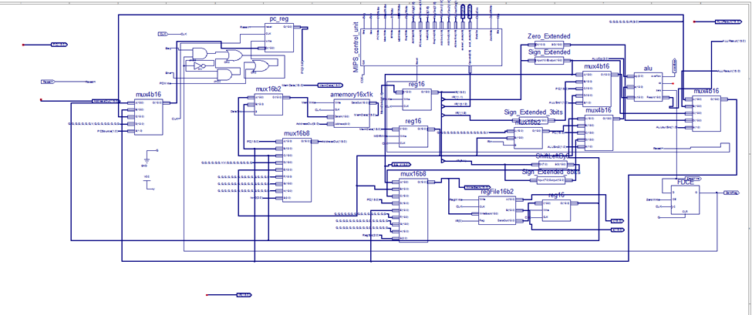

Testing

It was decided that we needed separate integration tests for the ALU, the PC, the memory, the registers (IR, I, BI, UA), the register file and R register, and the mux. These parts were all tested individually and then combined until the entire datapath was tested. For each component, the tests were executed by entering the appropriate-sized input bits and then turning the writes on and off to test each part.

Each part was first tested individually. The first test completed was the test of the ALU, followed by the test of the PC and all its parts. The next test was the Memory block, instruction register, and memory data register. The instruction register, immediate register, branch register, and upper address register were then tested. After those, the register file and R register were tested. The final individual test was the test of the muxes.

After the components were all tested individually, the components were combined into small chunks and tested. The first chunk tested was the PC and the Memory. The next chunk was the four different registers and the register file. The two chunks were then combined and tested. After that, the ALU was combined with the large chunk and tested. The final combination was the full datapath, with the final chunk being combined with the mux and the control unit.

To ensure that all the instructions were working as expected, the value produced by the test bench was compared to the state transition diagram built. This comparison of values allowed us to see which signal or state of the control unit was causing the problem in the test bench.

Final Result

Conclusion

Appendix A

Design Documentation

Milestone 1:

Ask Micah

Assembly Language Specifications:

This is an accumulator-based process with two registers. The first register, named $t, is used to save temporary values. The second register, named $s, is used to save values that will be needed in the future. We store instructions in address begin with 00000. Instead we store arguments begin with first 5bits of PC.

The instructions are as follows:

R-Type

Addition (with overflow): Put the value from register and value from specified address into ALU and then do addition. After that, send the result back into the register.

And: Put the value from register and value from specified address into ALU and then do “and” operation. After that, send the result back into the register.

Or: Put the value from register and value from specified address into ALU and then “or” operation. After that, send the result back into the register.

Subtract (with overflow): Put the difference of the register and specified address into the register.

Set Less Than: Set register to 1 if less than specified address, and to 0 otherwise.

Jump: Unconditionally jump to the instruction at the specified address.

Load Word: Load the 16 bit word at address into the register.

Store Word: Store the word from the register at address.

|  |  |  |  |
| --- | --- | --- | --- |
| Op  4 | Extra Space  3 | Address  8 | Register  1 |

I-Type

Addition Immediate (with overflow): Put the sum of the register and the sign-extended immediate into register.

And Immediate: Put the logical AND of register and sign-extended immediate into register.

Or Immediate: Put the logical OR of register and sign-extended immediate into register.

Load Upper Immediate: Loads the upper 8 bits of the immediate into the register.

Load Lower Immediate: Loads the lower 8 bits of the immediate into the register.

|  |  |  |
| --- | --- | --- |
| Op  4 | Immediate  11 | Register  1 |

B-Type

Branch on Equal: Conditionally branch the number of instructions specified by the function if the register equals the immediate.

Branch on Not Equal: Conditionally branch the number of instructions specified by the function if the register is not equal to the immediate.

|  |  |  |  |
| --- | --- | --- | --- |
| Op  4 | Immediate  3 | Address  8 | Register  1 |

Register Conventions:

We have 2 registers in our CPU design: one register is used to save temporary value named “$t”. The other is used to save value that need to be used in the future named “$s”

Machine Language Format: We have exactly 16 instructions so that we reserve 4-bits for operation code. When the value of “Register” equals 0, we use register $t, and when the value of “Register” equals 1, we use register $s.

R-type:

General instruction format:

|  |  |  |  |
| --- | --- | --- | --- |
| Op  4 | Extra Space  3 | Address  8 | Register  1 |

Add: add Addr reg. add the value in an address of a memory to the value in register, and then save the calculated value in register. Opcode: 0

And: and Addr reg. do “and” operation between the value in an address of a memory and the value in register, and then save the calculated value in register. Opcode: 1

Or: or Addr reg. do “or” operation between the value in an address of a memory and the value in register, and then save the calculated value in register. Opcode: 2

Sub: sub Addr reg. subtract the value in an address of a memory from the value in register, and then save the calculated value in register. Opcode: 3

Slt: slt Addr reg. Compare the value in an address of a memory with the value in register, and if the value in register is smaller, set the value of register to 1, otherwise, set it to 0

Opcode: 4

Jr: jr Addr reg. unconditionally jump to the instruction whose address is in the register. Opcode: 5

Sw: sw Addr reg. Store the 16 bit word of the register into at an address of memory the register. Opcode: 6

Jal: jal Addr reg. Unconditionally jump to the instruction at the specified address. Save the address of the next instruction in the register. Opcode: 7

Lw: lw Addr reg. Load the 16 bit word at an address of memory into the register.

Opcode: A

I-type:

|  |  |  |
| --- | --- | --- |
| Op  4 | Immediate  11 | Register  1 |

Addi: addi Imm reg. add the immediate value to the value in register, and then save the calculated value in register. Opcode: B

Li: li imm reg Load the immediate number to the register Opcode:F

B-Type

|  |  |  |  |
| --- | --- | --- | --- |
| Op  4 | BranchImmediate/Null  3 | Address/UpperImm  8 | Register  1 |

Beq: beq imm reg. DO Compare the value in an address of a memory with the value in register, if they are equal, branch. Opcode: 8

Lui: lua Imm reg. Load the first 8 bits of 16 bits address at an address of memory into the register. Opcode: E

Bne: bne Addr reg. DO Compare the value in an address of a memory with the value in register, if they are not equal, branch. Opcode: 9

N-Type

|  |  |  |  |
| --- | --- | --- | --- |
| Op  4 | BranchImmediate  3(001) | Address/UpperImm  8(00000000) | Register  1(1) |

Return: return . Return to the address that is stored in the $s(put that into PC), and puts the data from the address pointed by 0x0300 to $s Opcode: D (D201)

J-Type

|  |  |  |
| --- | --- | --- |
| Op  4 | Null  2(00) | Address  10 |

J: andi Imm reg. do jump operation and jump to the address that you like. Opcode: C

Rule for Translating:

Will use binary as machine language, to make it easier to be translated to hexadecimal or decimal. Example Assembly Language Programs and Assembly Language Fragments:

Load/Store Word and Exception

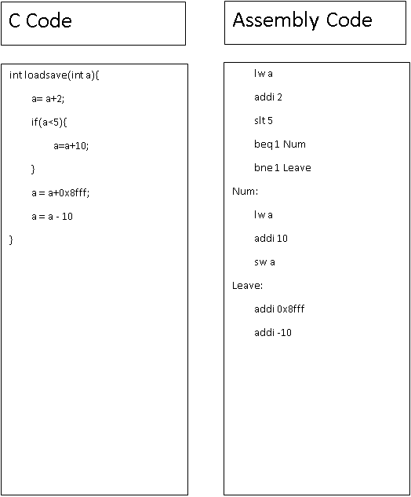

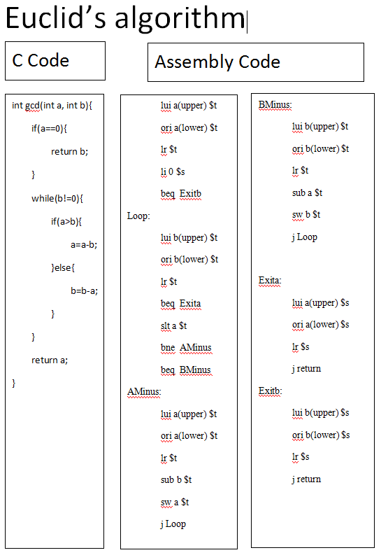

Load address:

lw a

Since the address is 16 bits while the instruction is 32 bits. There are 16 bits for the immediate which is enough to read any types of the data. “a” is a variable that stores a 16-bits address.

Iteration:

Loop:

“content of loop”

beq address Exit

j Loop

Exit:

“exit code”

This is a loop that makes the program goes over and over until the value in the register equals to the value in the specified memory address. When they equal, the program will go to the “Exit” address and finish the loop.

Conditional Statement:

beq(bne) address Target

j Else

Target:

“target content”

Else:

“else content”

This is an if statement. If the value of the register equals (not equal) to the data value in the specified address, then executes specified code in the “Target” address. Else, it will executes codes in the “Else” address.

Reading Data from Input Port: Undecided

Reading/Writing from Display Register: Undecided

Writing to Output Port: Undecided

Machine Language Translations:

**Euclid’s algorithm**

lui a(upper) $t

1111 000AAAAAAAA 0

ori a(lower) $t

1110 000AAAAAAAA 0

lr $t

0111 XXX XXXXXXXX 0

li 0 $s

0110 00000000000 1

beq Exitb

1010 XXX EXITBBBB X

Loop:

lui a(upper) $t

1111 000BBBBBBBB 0

ori a(lower) $t

1110 000BBBBBBBB 0

lr $t

0111 XXX XXXXXXXX 0

beq Exita

1010 XXX EXITAAAAA X

slt a $t

0100 XXX AAAAAAAA 0

bne AMinus

1011 XXX AMINUSSS X

beq BMinus

1010 XXX BMINUSSS X

AMinus:

lui a(upper) $t

1111 000BBBBBBBB 0

ori a(lower) $t

1110 000BBBBBBBB 0

lr $t

0111 XXX XXXXXXXX 0

sub b $t

0011 XXX BBBBBBBB 0

sw a $t

1000 XXX AAAAAAAA 0

j Loop

0101 XXX LOOPPPPP X

BMinus:

lui b(upper) $t

1111 000BBBBBBBB 0

ori b(lower) $t

1110 000BBBBBBBB 0

lr $t

0111 XXX XXXXXXXX 0

sub a $t

0011 XXX AAAAAAAA 0

sw b $t

1000 XXX BBBBBBBB 0

j Loop

0101 XXX LOOPPPPP X

Exita:

lui a(upper) $t

1111 000AAAAAAAA 0

ori a(lower) $t

1110 000AAAAAAAA 0

lr $t

0111 XXX XXXXXXXX 0

j return

0101 XXX RETURNNN X

Exitb:

lui b(upper) $t

1111 000BBBBBBBB 0

ori b(lower) $t

1110 000BBBBBBBB 0

lr $t

0111 XXX XXXXXXXX 0

j return

0101 XXX RETURNNN X

Load/Store words & Interrupt

lui a(upper) $t

1111 000AAAAAAAA 0

ori a(lower) $t

1110 000AAAAAAAA 0

lr $t

0111 XXX XXXXXXXX 0

addi 2 $t

1100 00000000010 0

sw a $t

1000 XXX AAAAAAAA 0

li 0 $s

0110 0000000000 1

addi 5 $s

1100 00000000101 1

sw b $s

1000 XXX BBBBBBBB 1

li $s

0110 00000000000 1

slt b $t

0100 XXX BBBBBBBB 0

bne Num

1011 XXX NUMMMMMM X

beq Leave

1010 XXX LEAVEEEE X

Num:

lui a(upper) $t

1111 000AAAAAAAA 0

ori a(lower) $t

1110 000AAAAAAAA 0

lr $t

0111 XXX XXXXXXXX 0

addi 10 $t

1100 00000001010 0

sw a $t

1000 XXX AAAAAAAA 0

Leave:

lui a(upper) $t

1111 000AAAAAAAA 0

ori a(lower) $t

1110 000AAAAAAAA 0

lr $t

0111 XXX XXXXXXXX 0

addi 0x8fff $t

1100 errorrrrr 0

addi -10 $t

1100 11110110 0

sw a $t

1000 XXX AAAAAAAA 0

Milestone 2:

RTL Code:

|  |  |  |  |  |  |  |
| --- | --- | --- | --- | --- | --- | --- |
| Step | and, or, sub, add, slt | lw, sw | | j | Jr | beq/bne |
| IF | IR = Mem[PC]  PC = PC + 1 | | | | | |
| ID | R = Reg[IR[0:0]]  I = IR[11:1]  BI = IR[11:9]  UA = IR[8:1]  ALUOut = PC + (SE((IR[11:1]))) | | | | | |
| EX  beq/j done | MDR = Mem[00000(I)] | MDR = Mem[(00000(I))] | Mem[((00000(I))] = R | PC = (000000IR[9:0]) | PC=ZE(Reg[IR[0:0]]) | If (R== BI)/(R!==BI)  Z = zero |
| MEM  and, or, etc. done | Reg[IR[0:0]] = R op MDR | Reg[IR[0:0]] = MDR | |  |  | Then PC = PC + R |

|  |  |  |  |  |  |
| --- | --- | --- | --- | --- | --- |
| Step | Jal | Addi | lui | li | return |
| IF | IR = Mem[PC]  PC = PC + 1 | | | | |
| ID | R = Reg[IR[0:0]]  I = IR[11:1]  BI = IR[11:9]  UA = IR[8:1]  ALUOut = PC + (SE(IR[11:1])) | | | | |
| EX  beq/j done | MDR = Mem[0x0300] | ALUOut(wire) = R + SE(I) | Reg[IR[0:0]] = SE(IR[8:1])<<8 | Reg[IR[0:0]]=SE(I) | PC = $s |
| MEM  and, or, etc. done | Mem[MDR] = $s | Reg[IR[0:0]] = ALUOut(wire) |  |  | 0x0300 =  Mem[0x0300] - 1 |
| lw done | 0x0300= Mem[0x0300] + 1 |  |  |  | $s = Mem[0x0300] |
| Procedure ALU | $s = PC |  |  |  |  |
| Procedure calls done | PC = (00000(I)) |  |  |  |  |

Components Needed:

* PC(program counter, which keeps tracking the address of current instruction)
* Memory(the place where instructions and memory stores)
* Instruction Register(the register where current instruction has been put)
* Register File(the place where deal with the load and store of registers)
* ALU(do simple operation with two inputs)
* Control Unit(translate the operation code to specified control signal bits)
* MDR(memory data register, which is used to store temporary value read from the memory.)
* I(for immediate)
* BI(for branch immediate)
* UA(for upper address use)
* R(for register)

Control Signals Needed:

* PCSource – to control the source of PC(0: R; 1:ALUout; 2:target address that going to jump after the j instruction)
* ALUsrc1 – to control the input of ALU(0:immediate; 1:branch immediate 2: 1)
* ALUsrc2 – to control the input of ALU(0:from register file; 1:MDR 2:PC)
* PCWrite – enable or disable writing to the PC (0: disable; 1:enable)
* MemRead – enable or disable reading from Memory (0: disable; 1:enable)
* IRWrite – enable or disable writing to Instruction Register (0: disable; 1:enable)
* RegWrite – enable or disable writing to Register File (0: disable; 1:enable)
* RegSrc – determines what goes to register (0: sign extended immediate; 1:MDR; 2:UA shifts left by 8; 3:PC; 4:ALUout)
* ALUoutSrc – determines what output should be in the ALUout (0: address begin with 5bits from PC; 1:result from ALU 2:sign extended immediate)
* ALUOp – determines what operation is used in the ALU
* IorD – to control which part should be write back.

Test Cases:(haven’t done yet)

Add: when an add instruction have been read from the instruction memory, for example:

“Add 0xfe $s”. It represents to add data from 0x10fe to register $s. We assume that $s stores a value like “5” and the value of 0x10fe to be “2”. Then, it should come out an answer of 7 in the register $s. We just need to check whether the Opcode is 0, the MDR should be 2 and ALUout should be 7.(Sub/or/and/slt are similar)

Lw:example: “lw b $t” We assume the address of b is 0x102a and the data in 0x102a should be 78. Thus, we should check MDR which should be 78 and Opcode should be A. ALUout should be the full address which is 0x102a.

Sw: example: “sw b $t”. We assume the address of b is 0x102a. We assume the value of $t would be 6. We should check ALUouy be the full address of b, which is 0x102a. Also, we should check the value of register $t after that. It should have a value of 6.

J: example: “j 0x08fe” This one should check whether PC is 0x08fe after the instruction has been done.

Jr: example: “jr $t” We assume that the address stores in the $t is 0x063a. After we finish the execution of the instruction, the value of PC should be 0x063a.

Beq/bne: example: “beq $t 4 A” We assume that the value stores in $t is 4. We assume A has the address 0x10b8 and PC is 0x10a5 Thus, we should check whether the PC after the execution is 0x10b8. Also, we should check the value of register A is 4 and register B is 4.

(bne is similar)

Jal: example: “jal 0xfe $t” This one should check whether PC is 0x10fe or not. We assume the address of “jal 0xfe $t” is 0x1050 0x Also, we should check whether $t contains current address of “jal 0xfe $t”, which should be 0x1052 then.

Addi/ori/andi: “addi 0xa2 $t” We assume that register t has a value of 8. Then, after the execution of this instruction, the value of $t should be 170.

Lui: example: “lui 0xea $t” After executing the instruction, we should check whether the value of $t is 0xea00 or not.

Li: example: “li 0x34 $t” After executing the instruction, we should check whether the value of $t is 0x34 or not.

DataPath:

df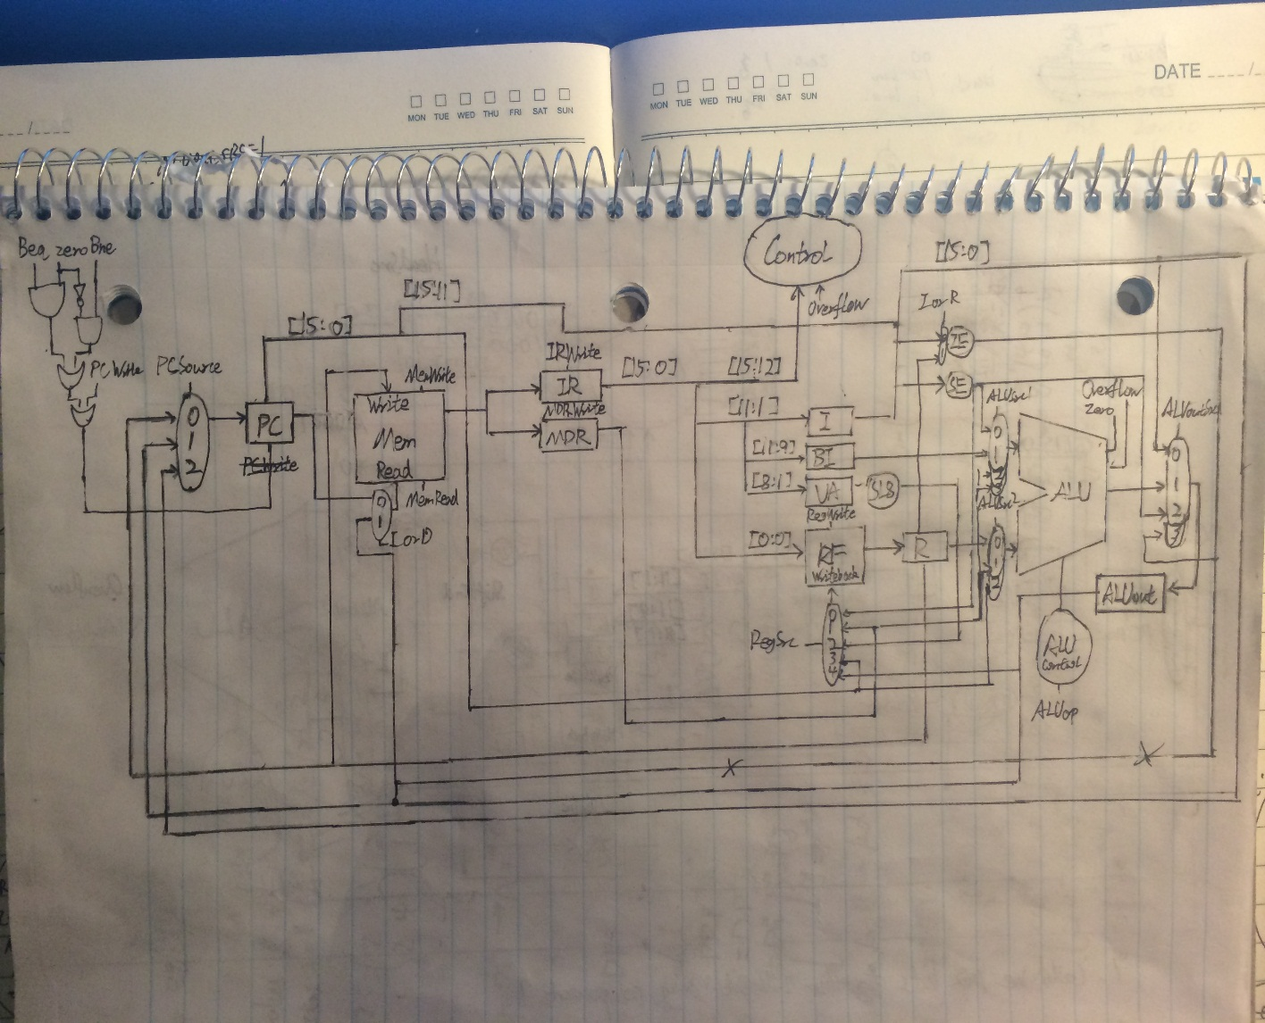

Necessary Testing

Unit Testing:

To correctly test this data path, multiple testbenches must be implemented to verify the implementation. There must a separate test for the memory, control, ALU, IR, and MDR. But also another overall test for the overall schematic. The test for memory, must be provided addresses and all inputs, outputs, and registers initialized. The test for the control, will the most difficult it will require the most attention to detail, but after given the necessary inputs it should be able to run autonomously. The test for the ALU can be broken down to the different operations. The test for the IR and MDR can be similar as they are both registers. In the schematic test bench, there must be a file loaded into created memory block that provides the processor with all of the necessary opcodes for the instructions that need to be executed. All of these test should run smoothly if the datapath is implemented correctly and if the path is not correct can point the group in the appropriate area that needs correction.

Integration Testing:

The integration testing will be implement by splitting the datapath up into smaller chunks and tested until satisfaction. Then it will be built bottom up and written in the fashion of our RTL code. Right now, we are thinking we could began our tests by testing in procedures as follow:

1. ALU tests
2. Bne/Zero/Beq/PCWrite + PC part tests
3. Memory block + Instruction register + Memory Data register tests
4. Part 2 + part 3 tests
5. Instruction register + immediate register + branch register + upper address register

tests

1. Register file + R register tests
2. Mux tests
3. Part 5 + part 6 tests
4. Part 4 + part 8 tests
5. Part 1 + part 10 tests
6. Part 10 + control unit tests + mux tests (which is the system tests then)

How to implement each part in Xilinx:

PC/IR/MDR/ALUout: It’s a register that has 16 bits, we could use flip-flop to implement that.

Memory: It’s a block memory that could implement by using the example memory block. (Or using block memory generator to create one)

Mux: We could use symbols from the Xilinx.

I: It’s a register that has 11 bits, we could use flip-flop to implement that.

BI: It’s a register that has 3 bits, we could use flip-flop to implement that.

UA: It’s a register that has 8 bits, we could use flip-flop to implement that.

R: It’s a one bit register, we could use the basic symbol in Xilinx to implement that.

Register file: Use example in Final Project Resources as reference.

Shift left 8: could use Xilinx code to implement that.

Zero Extend: Use Verilog to implement that.

Sign Extend: Use Xilinx wire graph to implement that.

ALU: finished in lab6, but need to change it to 16-bits.

Control: could use Xilinx code to implement that(use cases to implement).

Test RTL

Test of state 1(Instruction Fetch)

Check to see the value assigned into state 1 had plus 1 or not.

Example:

PC=0x8000

Add 0x7a6 $t

PC expect: 8001

Test of state2 (Inst Decode Register Fetch)

After state 2. Just check the register R, I, BI, UA and ALUOut store the right value from Reg[IR[0:0]], IR[11:1], IR[11:9], IR[8:1], and PC + (SE((IR[11:1]) <<1)) respectively.

Example:

PC=0x8000/ $t =5; 0x0ef6 = 12

Add 0x77b $t

R expect: 5; I expect: 0x77b; BI expect: 0x7; UA expect: 0x7b; ALUout expect: 17

Test of state3

1.Add

Make ALU do the add operation and check if the number will be overflow

Example:

$t =5; 0x0ef6 = 12

Add 0x77b $t

Reg[IR[0-0]] = R = ALUout expect: 17

Example:

$t = 10; 0x0ef6 = 0xfffe

Add 0x77b $t

Overflow expect: 1

2.sub

3.or

4.add

5.Slt

6.lw

7.sw

8.j

9.jr

10.beq

11.bne

12.jal

13.addi

14.andi

15.li

16.lui

Test of state4

1. and, or, sub, add, slt

Check that Reg[IR[0:0]] contains the value stores in ALUout.

Example:

$t =5; 0x0ef6 = 12

Add 0x77b $t

Reg[IR[0-0]]:R expect: 17

2. sw

Check the value of specified address is the value of register R

Example:

$t =0x002a; 0x0ef6 = 12

Sw 0x77b , $t

Expect: MEM[ALUout]=12 = R

1. lw

Check the value of the MDR is the same value in the specified address.

Example:

0x0ef6 = 12

Lw 0x77b, $t

Expect: $t = Mem[ALUout]

Test of state5

1. lw

Check if the Reg[IR[0:0]] contains the value stores in MDR.

Example:

0x0ef6 = 12

Lw 0x77b, $t

Expect: Reg[IR[0:0]]=$t

We use FSM to implement control unit.

State transition diagram/table:

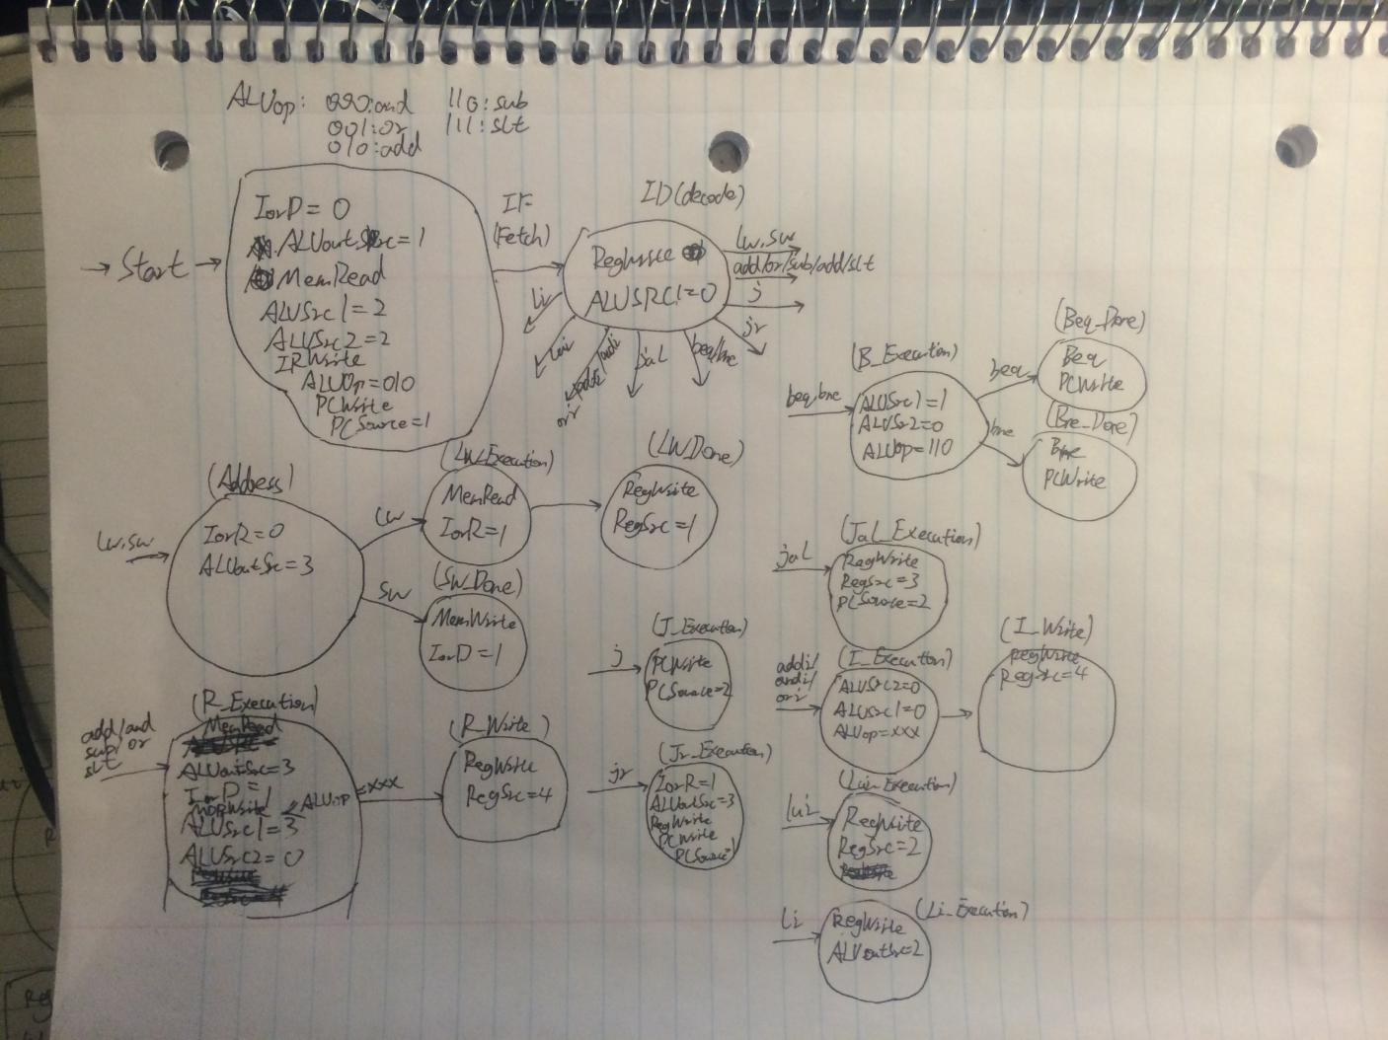

Test necessary to verify the correct implementation of the control unit:

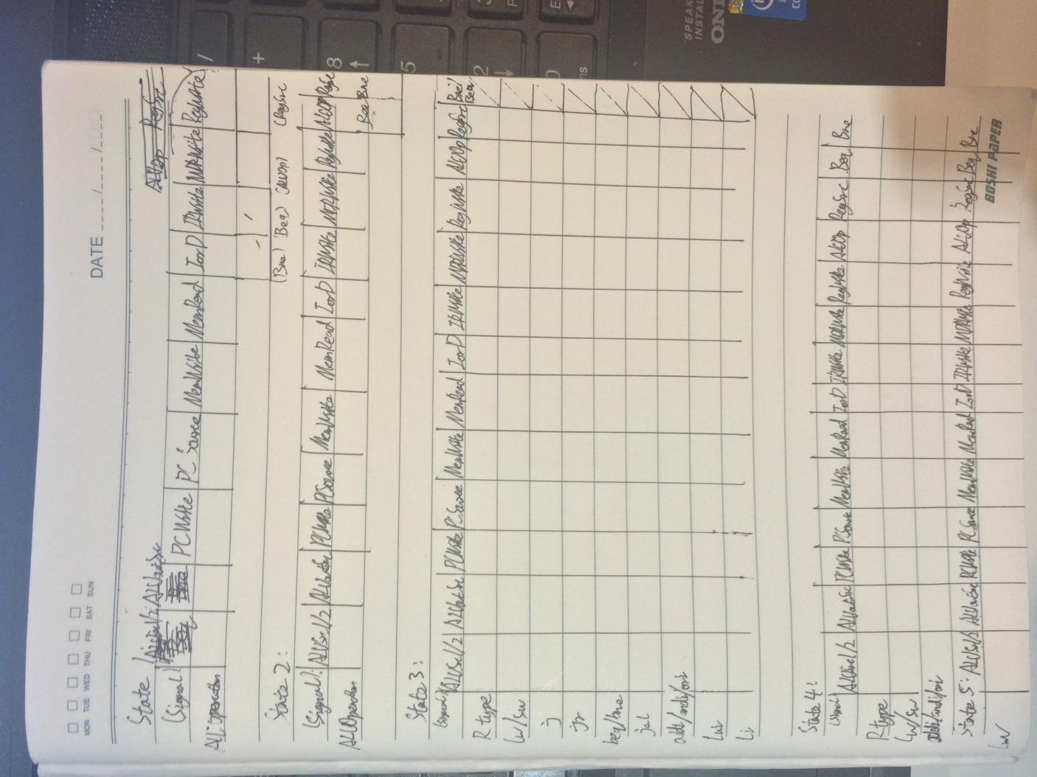

In order to make sure that every types of instructions run well in different states, we need to make a table that records the bits of signal that we get from the test bench. Then, we need to compare this table with the state transition diagram and try to find those in-correspond values. Those in-correspond values could make us find out which signal and what state that our control unit goes wrong.

Changes to the signals and RTL:

There is no longer MemWrite Signal or IorR signal. Instead, there is one more port with the number of two in the MemRead mux and a new port with number of three in the ALUSrc2. (which is the merge of the first 8 bits of PC and 8 bits of immediate ).The newest version of the datapath is implemented in Xilinx. Also, we delete addi and ori to add the return instruction and the J instruction. (We want to do the procedure call; addi and ori are not commonly used) Cause, we need to keep the number of instructions to 16. (Jal is not designed correctly, already fixed that in the RTL, need to create a stack that stores return value, we assigned the 0x3000 to be the stack pointer of the stack begin from 0x2000. what we are considering is to have $s to keep the current return address.) However, due to the changes that we made to the RTL, we need to change the control unit and the datapath which is not fully implemented yet.

System Test Plan:

For the integration tests, we should test the whole datapath with all of the instructions that we have. In order to test all of them, we could write short programs and translate them to machine code to put them into the memory. The machine code could be finished according to the opcode and the translation rules that we already given in Milestone 1 and 2. Then, we just need to check whether the value of each components correspond to what we expected. Also, we could run the Euclid algorithm by giving the machine code to the memory. (In order to test the procedure call)

R-Type:

PC = 0x1000

Mem[0x0000] = 10

Mem[0x0001] = 4

$t = 10

$s = 2

Add 0x001 $t

Sub 0x001 $s

And 0x000 $s

Or 0x001 $t

Slt 0x000 $t

Expected:

$t = 1

$s = 10

Lw and Sw:

PC = 0x1000

Mem[0x0000] = 10

Mem[0x0001] = 4

$t = 10

$s = 2

Lw 0x000 $t

Add 0x001 $t

Sw 0x000 $t

Expected:

$t = 14

Mem[0x0000] = 14

Jr:

PC = 0x1000

Mem[0x0000] = 10

Mem[0x0001] = 4

$t = 10

$s = 0x1005

0x1000 Add 0x001 $t

0x1001 Jr $s

0x1002 Add 0x001 $t

0x1003 Add 0x000 $t

0x1004 Sub 0x000 $t

0x1005 Sub 0x001 $t

Expected:

$t = 10

Beq & Bne:

PC = 0x1000

Mem[0x0000] = 10

Mem[0x0001] = 4

$t = 2

$s = 0x1005

0x1000 Add 0x001 $t

0x1001 Beq 4 0x 05 $t

0x1002 Add 0x001 $t

0x1003 Add 0x000 $t

0x1004 Sub 0x000 $t

0x1005 Sub 0x001 $t

Expected:

$t = 2

PC = 0x1000

Mem[0x0000] = 10

Mem[0x0001] = 4

$t = 2

$s = 0x1005

0x1000 Add 0x001 $t

0x1001 Bne 0 0x 05 $t

0x1002 Add 0x001 $t

0x1003 Add 0x000 $t

0x1004 Sub 0x000 $t

0x1005 Sub 0x001 $t

Expected:

$t = 2

Jal & Jr:

PC = 0x1000

Mem[0x0000] = 1

Mem[0x0001] = -1

$t = 0

$s = 2

0x1000 Add 0x001 $t

0x1001 Jal 0x004 $t

0x1002 Add 0x001 $t

0x1003 li 0x000 $t

0x1004 beq 0 0x00 $t.

0x1005 Sub 0x001 $t

0x1006 Jr $t

0x1007 Sw $t

Expected:

$t = 0

I-Type:

PC = 0x1000

Mem[0x0000] = 10

Mem[0x0001] = 4

$t = 10

$s = 2

Addi 0xff5 $t

Ori 0x001 $t

andi 0x001 $t

Expected:

$t = 0x0fff

Lui:

PC = 0x1000

Mem[0x0000] = 10

Mem[0x0001] = 4

$t = 10

$s = 2

Lui 0x01 $t

Expected:

$t = 0x0100

Li:

PC = 0x1000

Mem[0x0000] = 10

Mem[0x0001] = 4

$t = 10

$s = 2

Li 0x001 $s

Expected:

$s = 4

Appendix B

Design Process Journal

Milestone 1:

The CPU of choice is an accumulator because it only has one register, do not need any bits to store the register, and it is faster than load word. Encountered first problem, cannot compare two instructions, must think of ways around this. Another problem occurred trying to implement shift with the ALU. Confused at where to put the parameters in the code for the algorithm. We have decided to use hexadecimal for machine language, it would be easier to keep track of and understand.

Milestone 2:

Discussed in the meeting on 10/12/14 was the new amount of registers and resizing the instructions. We have settled on using 2 registers and making instructions 16 bits. Also, the instructions list has been revisited and several were deleted after discussing their usefulness.

Discussed in the meeting on 10/13/14 was how to make our datapath. It was decided to make a multi-cycle processor. The datapath was drawn in order to assist in the writing of the RTL code.

Discussed in the meeting on 10/14/14 was more of the datapath. It was decided that all of the parts of a traditional multicycle datapath would be needed for our datapath. The different control signals were also decided. We decided we did not need PCWriteCond, IorD, MemWrite, and RegDst because we are only using two registers. A new signal called WriteBlocker was added. We also discussed how to write the RTL code. Complication arose in converting the multicycle RTL to RTL that uses our types, our size of 16 bits, and our choice of fewer registers. RTL code was written for every instruction or set of similar instructions.

Milestone 3:

Discussed at the meeting on 10/20/14 was updates to Milestone 2. The RTL code was updated to reflect the meeting with Micah on 10/17/14. The datapath was also discussed. The datapath was completed with all the necessary parts and was begun to be implemented in Xilinx.

Discussed at the meeting on 10/21/14 was how the test cases would be implemented.

Milestone 4:

Most of milestone 4 was preparing the tests necessary to verify the control unit, the actual testbench was actually started early. Components takes unexpected long time to finish, also the testbench. The main problem is focusing on the testbench. There were 3 short meetings, one on 10/24/14 to finish the code for the control and create the symbols for the various components. The second meeting 10/26/14 was to finish up the specifications, and another short meeting on 10/27/14 to wrap up all documentation.

Milestone 5:

Headed into Milestone 5 the control unit test was almost finished and most components had been successfully tested. On 11/3/14 the control unit test was finished and integration testing was updated. On 11/4/14 the ALU16 and RegFile were fixed, the complete Xilinx model implemented, and the system test plan was begun.

Milestone 6:

Integration testing was begun on 11/08/14. Changes were made to the RTL, control unit, and machine code. Integration testing was completed on 11/12/14. System testing was begun on 11/13/14 and is still in progress.

Appendix C

Test Results